Reception Early Years Foundation Stage
 | Autumn 1 | Autumn 2 | Spring 1 | Spring 2 | Summer 1 | Summer 2
 | Fantastic Me | Ice Explorers | There’s a hero in everyone | Tell me a story | Amazing Animals | Travel & Transport
 | All about Me  All about my family  We will learn and celebrate the importance our place in the community and world.  We will celebrate our individuality and the similarities between us all. | Ice Explorers! -Come on an adventure to the icy lands of the Arctic and Antarctica, you will need to wrap up warm | What makes a hero?  How can you bring out the superhero in yourself?  People who help us in our community | Traditional tales  We will enter the world of traditional tales, retelling stories and sequencing events | Animals around the world  We will go on an animal adventure, finding out their different habitats, types of animals and the importance of caring for them. | There are many different types of transport.  We will explore how we can travel from place to another  Talk about past events, such as places we have visited and the transported we needed to use to go on our journeys.
Literacy and suggested text  Taught alongside systematic phonics | 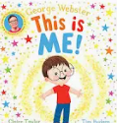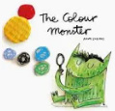  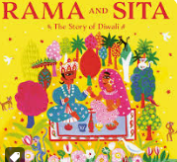 | 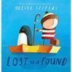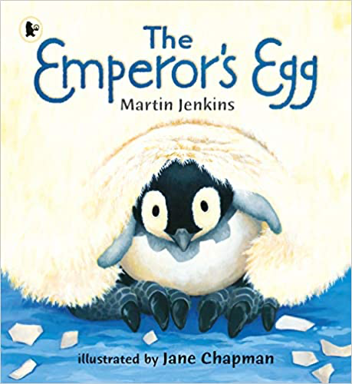  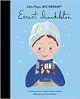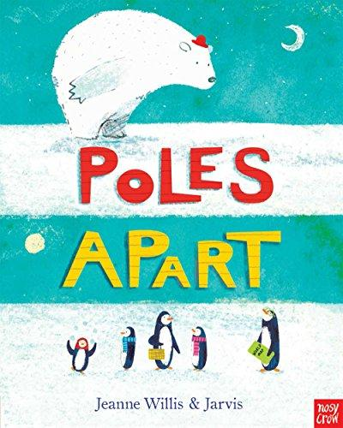  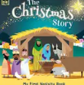 | 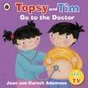  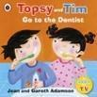  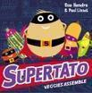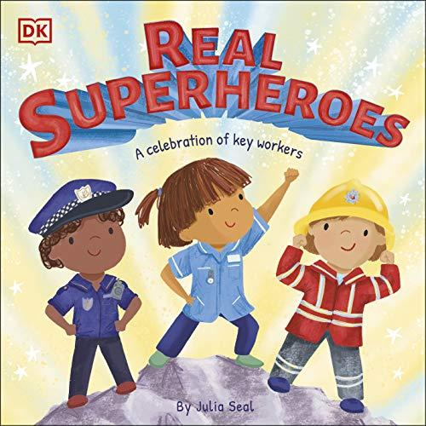  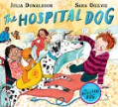 | 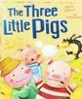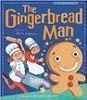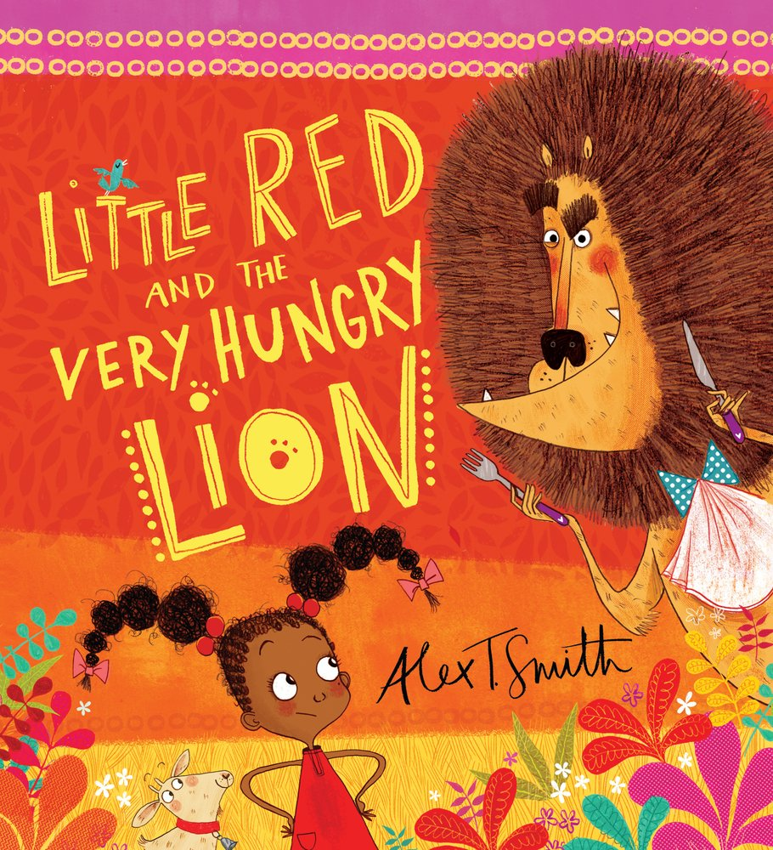  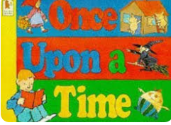 | 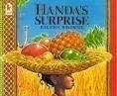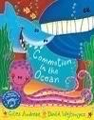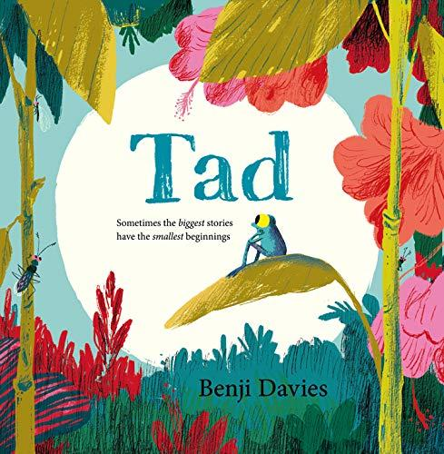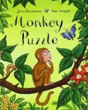 | 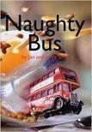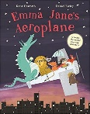  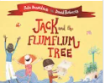  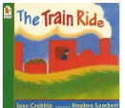
Communication & Language | Respond to simple instructions, e.g., we will put on our coats as it is raining outside.  Join in with repeating refrains and anticipating key events and phrases in rhymes and stories,  Chatterboxes from home | Winter themed curiosity cube  Special basket of fiction and non-fiction winter themed books  Discuss how we keep ourselves when we go outside on cold days | Question to understand why things happen e.g., who, what, when how.  Superhero walkie talkies  Superhero finger puppets  What would your superhero power be? | Use talk to explain what is happening and what might happen next e.g. discussing how  Make predictions about shared stories | Understand ‘how’ and ‘why’ questions, relating them to growing and changing e.g.what has stayed the same, what has changed?  How the animal changed/grown? | Use different tenses to discuss things that are happening now and things that happened in the past, and things that happened a very long time ago,  Talk about and share journey’s we have been on
Physical  Gross | Introduction to PE Unit 1  Outside  Large chalk faces  Colourful ribbons to talk about different feelings | Fundamentals Unit 1  Outside  Using boxes and large construction to make and build sledges  Creating ice caves (den building) | Gymnastics Unit 2  Outside  People who help us dressing up  Superhero obstacle course  Superhero targets  Go Noodle super hero movement break  Construction site- Role play | Movement Development  Outside  Den building- constructing house  What’s the time Mr Wolf | Ball Skills Unit 1  Throwing and catching  Aiming  Outside  Target practise | Games Unit 1  Sports day practise  Sports Day
Physical  Fine | Support children managing themselves, buttons, coats, zips  Dominant hand  Mark making  Left to right  Drawing my family/portraits  Funky fingers:  Playdough, rollers, cutters  Tweezers  Scissors  Being healthy- fruit kebabs, pink playdough and white pegs for rows of teeth  Toothbrushes | Cornflour gloop  Tweezers and white pom poms and cotton balls to create a snowman  Number and letter formation in shaving foam and pretend snow  Funky fingers:  Playdough, rollers, cutters  Tweezers  Scissors | Water pistols/Spray bottles (outside)  Chalks (outside)  Snipping paper  Neon yellow playdough  Funky fingers  Playdough  Cutting and joining  Threading  Small construction | Drawing characters from the story  Sequencing pictures from a well-known story using washing lines and pegs  Funky fingers  Playdough  Cutting and joining  Pegs | Paper chain animals  Playdough animals  Drawing animals  Funky fingers  Playdough  Cutting and joining  Threading  Small construction | Drawing maps,  Drawing vehicles  Funky fingers  Playdough  Cutting and joining  Threading  Small construction
Personal, social and Emotional Development | Settling in  Our rules: how we all help to make our classroom a happy place to learn.  My feelings: words I can use to describe how I am feeling.  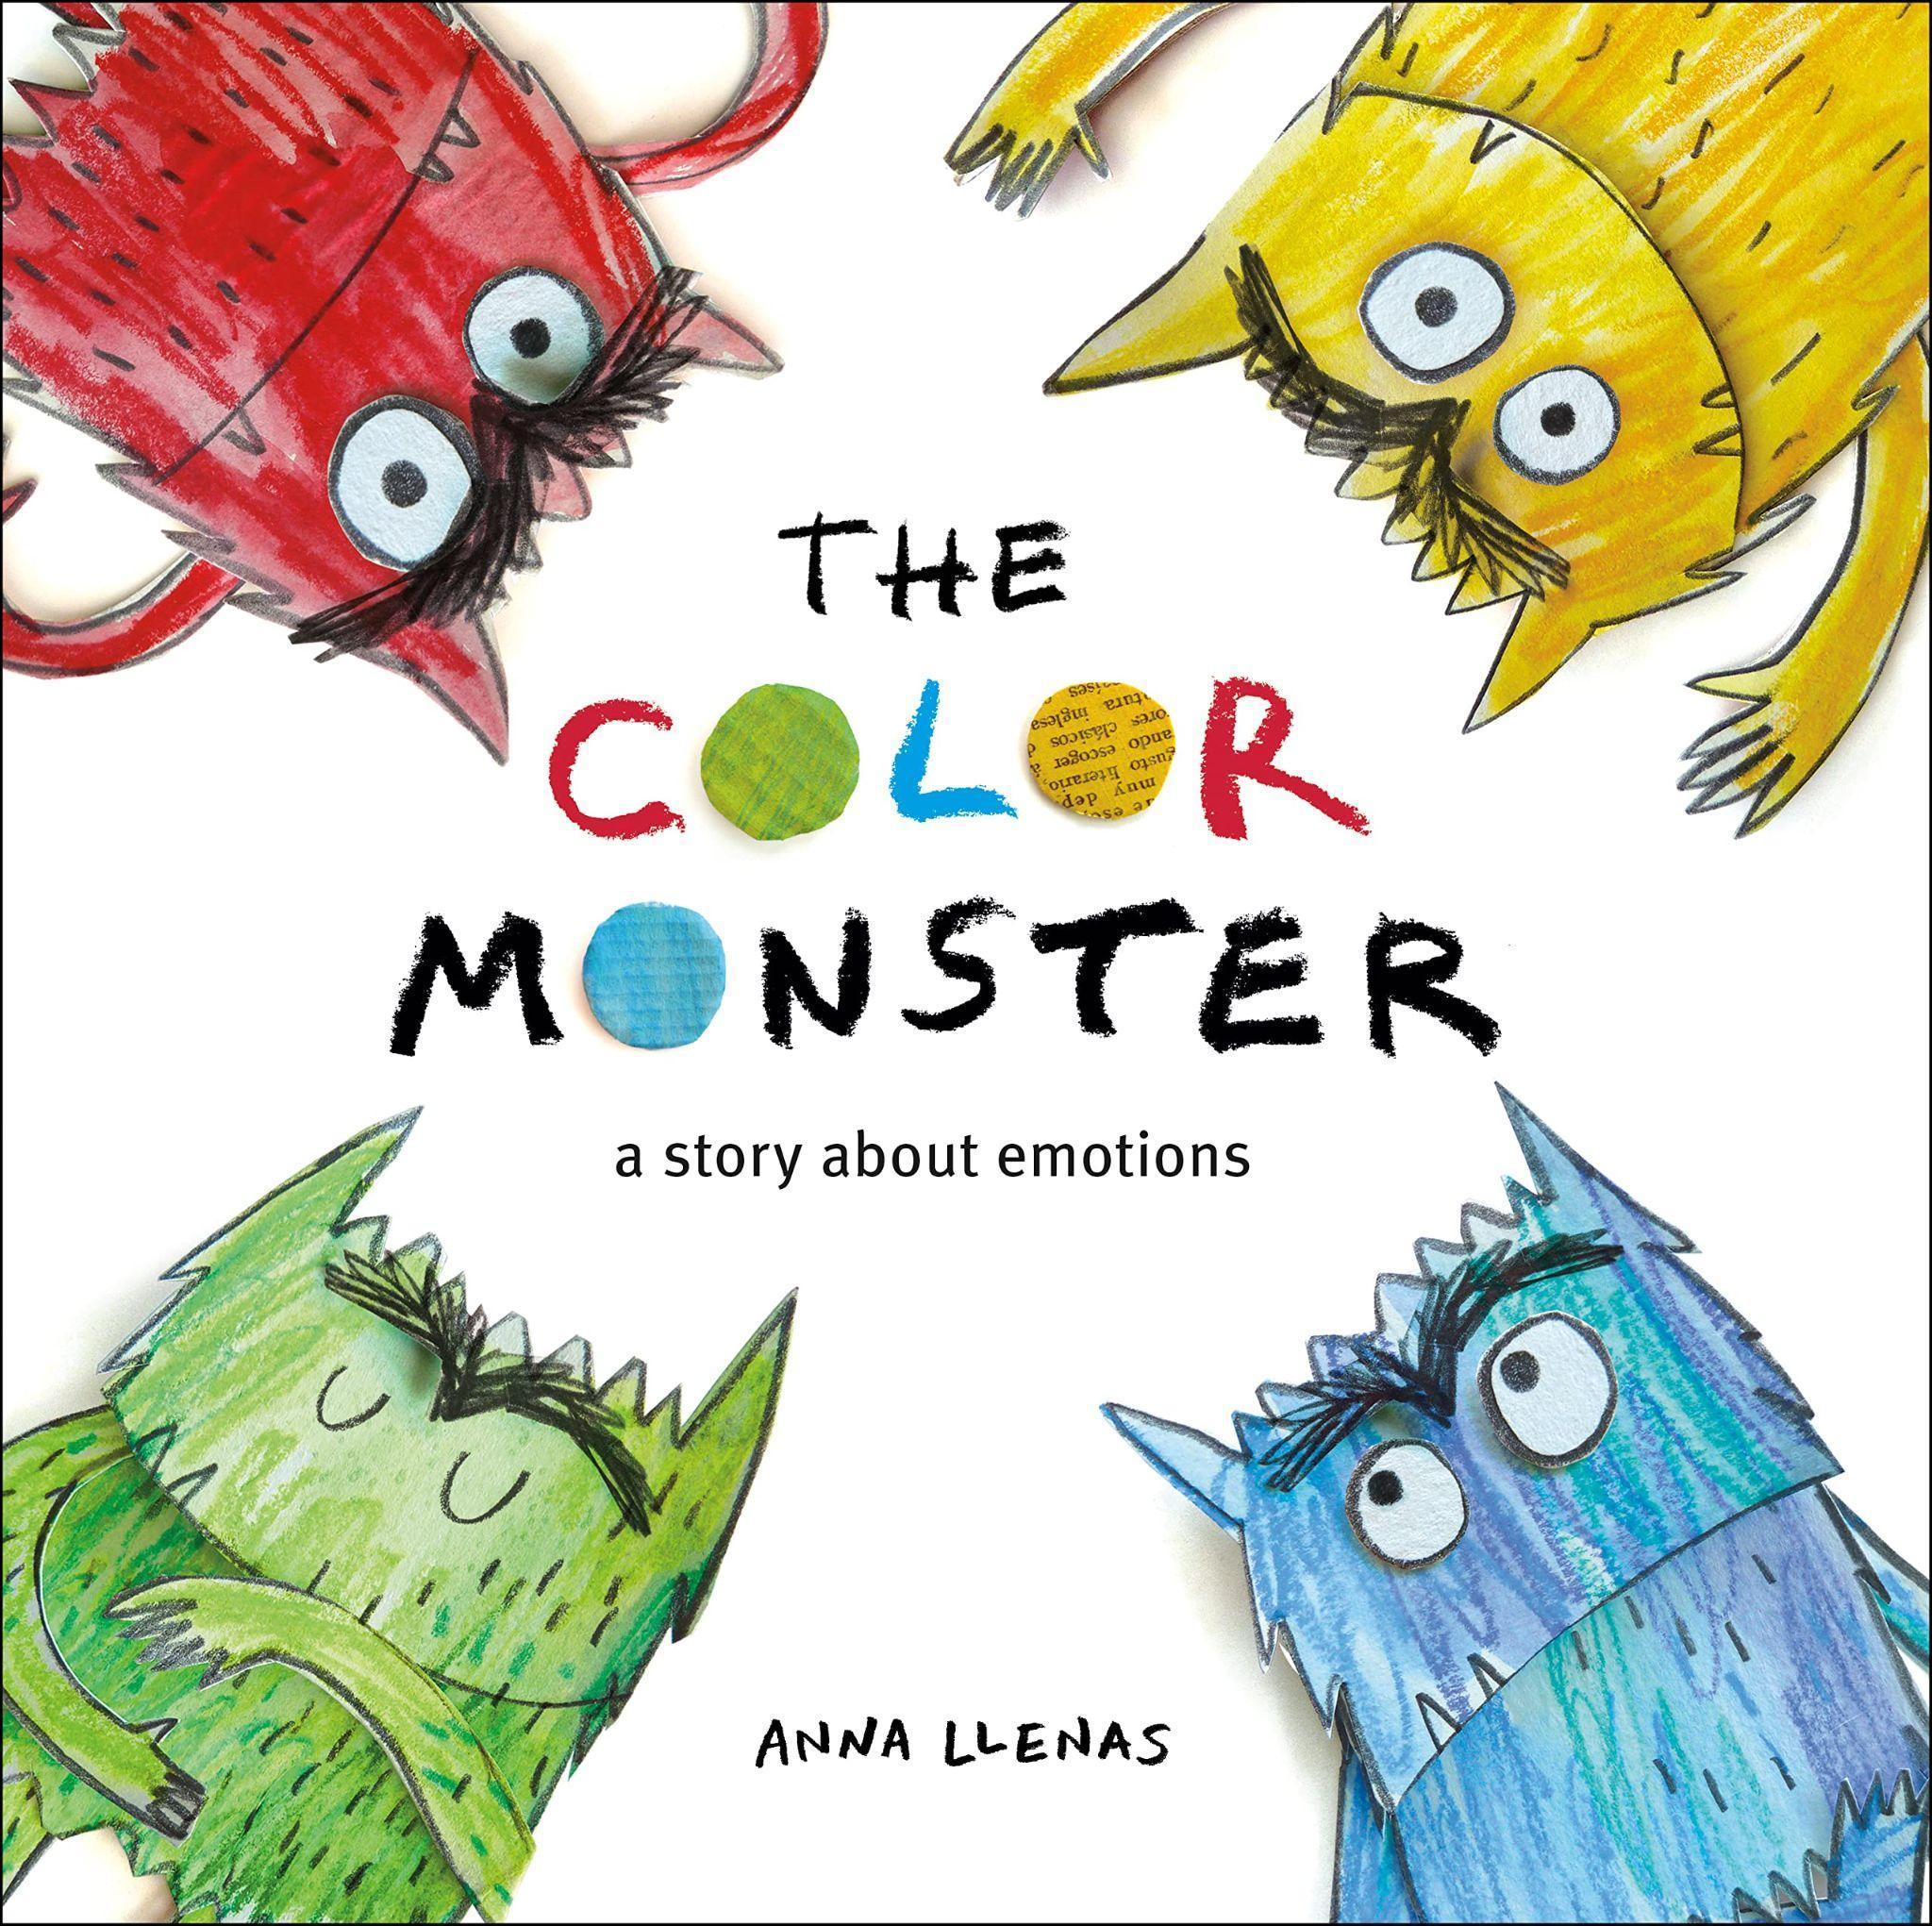  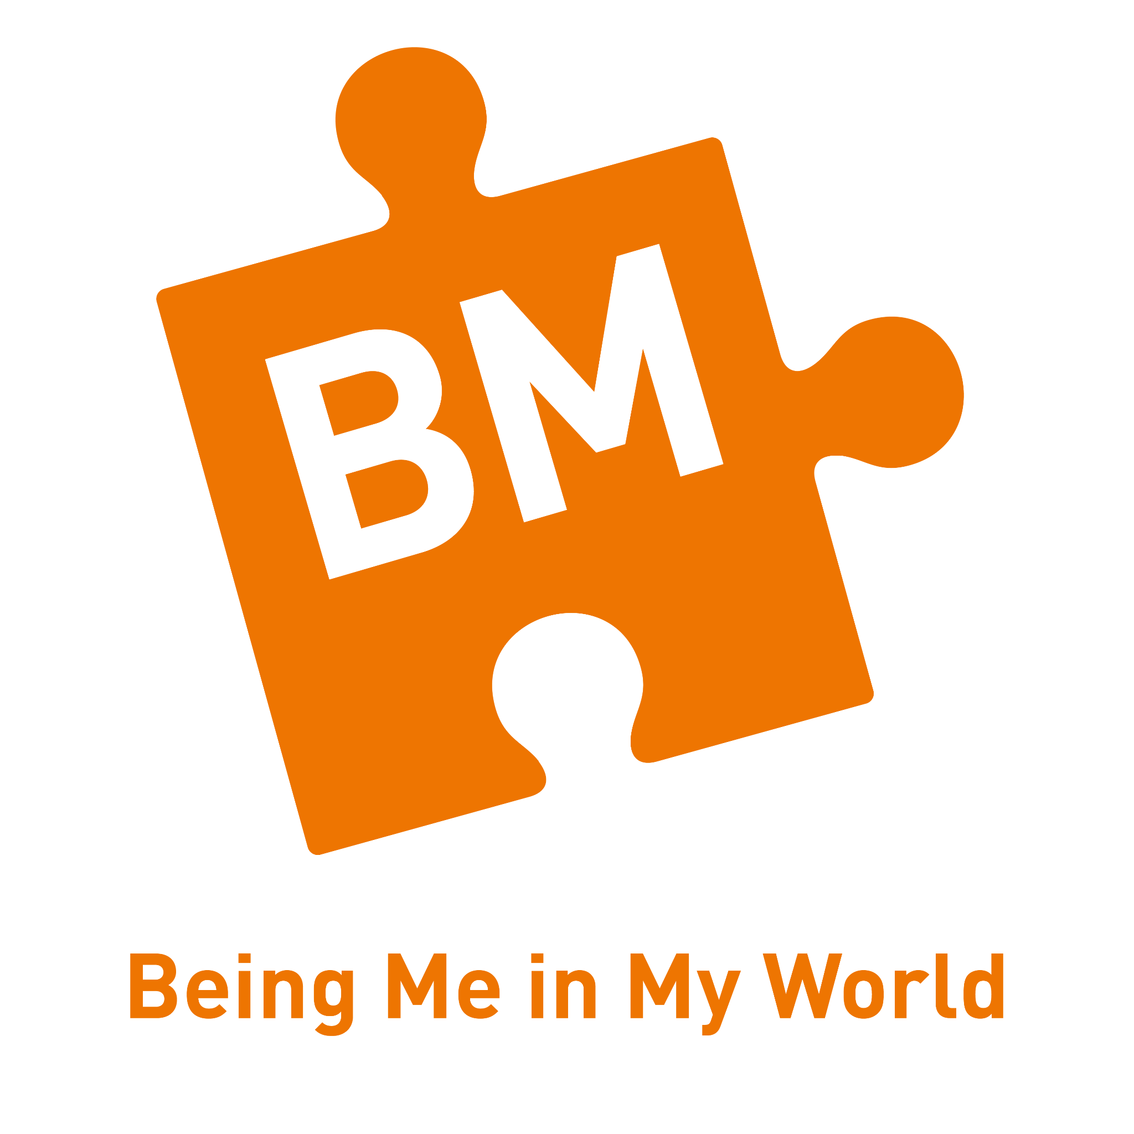  -Who…Me?  -How am I feeling today?  -Being at school  -Gentle hands  -Our rights- school charter  -Our responsibility |   -What am I good at?  -I’m special I’m me  -Families  -Homes  -Making friends  -Standing up for yourself |   -Challenge  -Never giving up  -Setting a goal  -Obstacles and support  -Flight to the future  -Footprint awards | 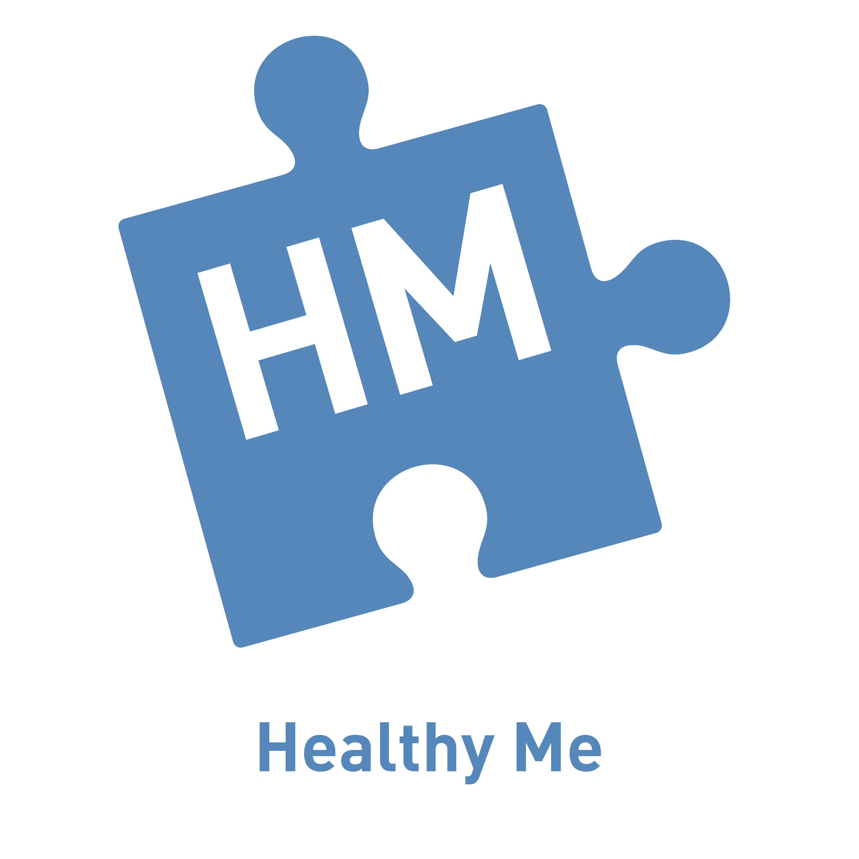  -Everyone’s body  -We like to move it, move it  -Food glorious food  -Sweet dreams  -Keeping clean  -Safe adults | 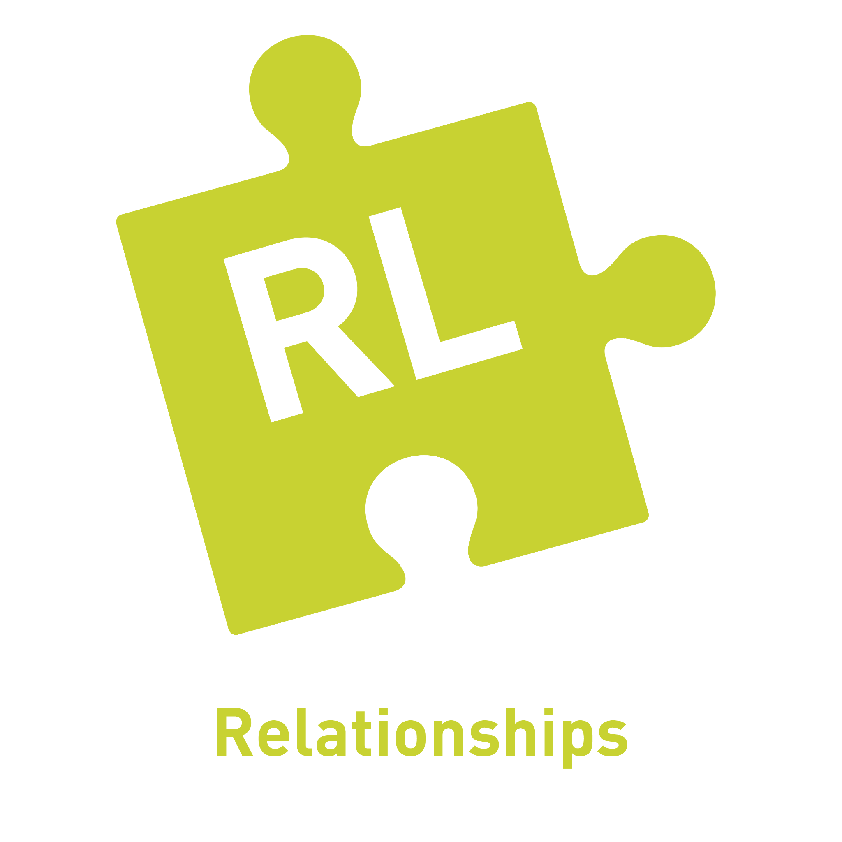  -My family and me  -Make friends, make friends, never ever break friends  -Falling out and bullying  -Being the best friends we can be |   -My body  -Resecting my body  -Grown up  -Fun and fears  -Celebration
Literacy | Retell stories using puppets, props, drawings and own imagination  Provide opportunities for mark making e.g. printing with paints  Letter formation  Name writing  Segmenting and blending | Letter formation  Name writing  Simple sentence writing  Frozen letters for children to explore and recognise  Outside winter reading cave  cvc words | Letter formation  Sentence writing  Capital letters and full stops  cvc words  Thank you card for someone who has helped them | Create a storyboard to retell traditional tales  Join in with the repeating refrains in the  Letter formation  Independent sentence writing  Capital letters and full stops  Speech bubbles  Story sacks | Join in with the repeating refrains in the  Letter formation  Independent sentence writing  Capital letters and full stops  Speech bubbles  Story sacks  Story maps | Join in with the repeating refrains in the  Letter formation  Independent sentence writing  Capital letters and full stops  Speech bubbles  Story sacks  Story maps
Phonics | Read Write Inc expectations  Set 1 phonemes  Fred words  Fred talk | Read Write Inc expectations  Set 1 phonemes  Fred words  Fred talk | Read Write Inc expectations  Set 1 and 2 phonemes  Fred words  Fred talk  Ditty books | Read Write Inc expectations  Set 1 and 2  Fred words  Fred talk  Red Ditty storybooks | Read Write Inc expectations  Set 1 and 2  Fred words  Fred talk  Green storybooks | Read Write Inc expectations  Set 1 and 2  Fred words  Fred talk  Green/Purple storybooks
Mathematics | White Rose Maths  Maths Mastery  -Numbers: 12345  -Representing  -Composition  -Subitising  -1 more  -1 less  Regular referral to calendar, weather, days of the week,  months of the year  Links with Numberblocks | White Rose Maths  Maths Mastery  -Numbers 123456789  - Representing  -Composition  -Subitising  -1 more  -1 less  -Odd and Even numbers  Regular referral to calendar, weather, days of the week, months of the year  Links with Numberblocks | White Rose Maths  Maths Mastery  -Numbers 12345678910  -Making arrangements  -Doubling  -Combining groups  -Odd and Even numbers  Regular referral to calendar, weather, days of the week,  months of the year  Links with Numberblocks | White Rose Maths  Maths Mastery  -Numbers to 20  -2d shapes  -Explore sharing  -Explore grouping  Regular referral to calendar, weather, days of the week,  months of the year  Links with Numberblocks | White Rose Maths  Maths Mastery  -To beyond 20  -Sharing and grouping  -How many now?  -3d shapes  Regular referral to calendar, weather, days of the week,  months of the year  Links with Numberblocks | White Rose Maths  Maths Mastery  -Length, height and weight  -Visualise build and map  -Mass and capacity  Regular referral to calendar, weather, days of the week,  months of the year  Links with Numberblocks
UW | History  Family Trees (grandparents, great-grandparents)  When I was a baby  Developing sense of chronology; before I was born, before I came to school, when I go to school  Geography  Where I live map  Things I see on my way to school  Science  Our 5 senses  Teeth | Science  Exploring melting of ice  ‘trapped’ frozen characters to rescue  Frozen natural objects to explore with magnifying glasses  Geography  Where is Antarctica, north pole, south pole  History  Who was Ernest Shackleton? | Science-  Growing  Healthy Eating  Geography-  Recycling  Creating road signs (outside)  People who help us and their roles to the community- visitors  History  Compare and contrast uniforms and modes of transport from past to present.  What has stayed the same and what is different. | Science- Materials  Torches-light and dark  Shadows  Geography  Talk about the different places the core books are based/located  Talk about different types of buildings  Maps- local maps, classroom/playground maps | Science- Life cycles: chicks, tadpoles  Floating and sinking  To find out what pets need to keep  them safe, healthy, and happy  Recognise and use the following vocabulary:  Farm Animals: cow/calf, pig/piglet, sheep/lamb, chicken/chick, horse/foal  To explore the animals that have been extinct or in danger, such as Black rhino, or danger such as polar bear, gorilla, tiger  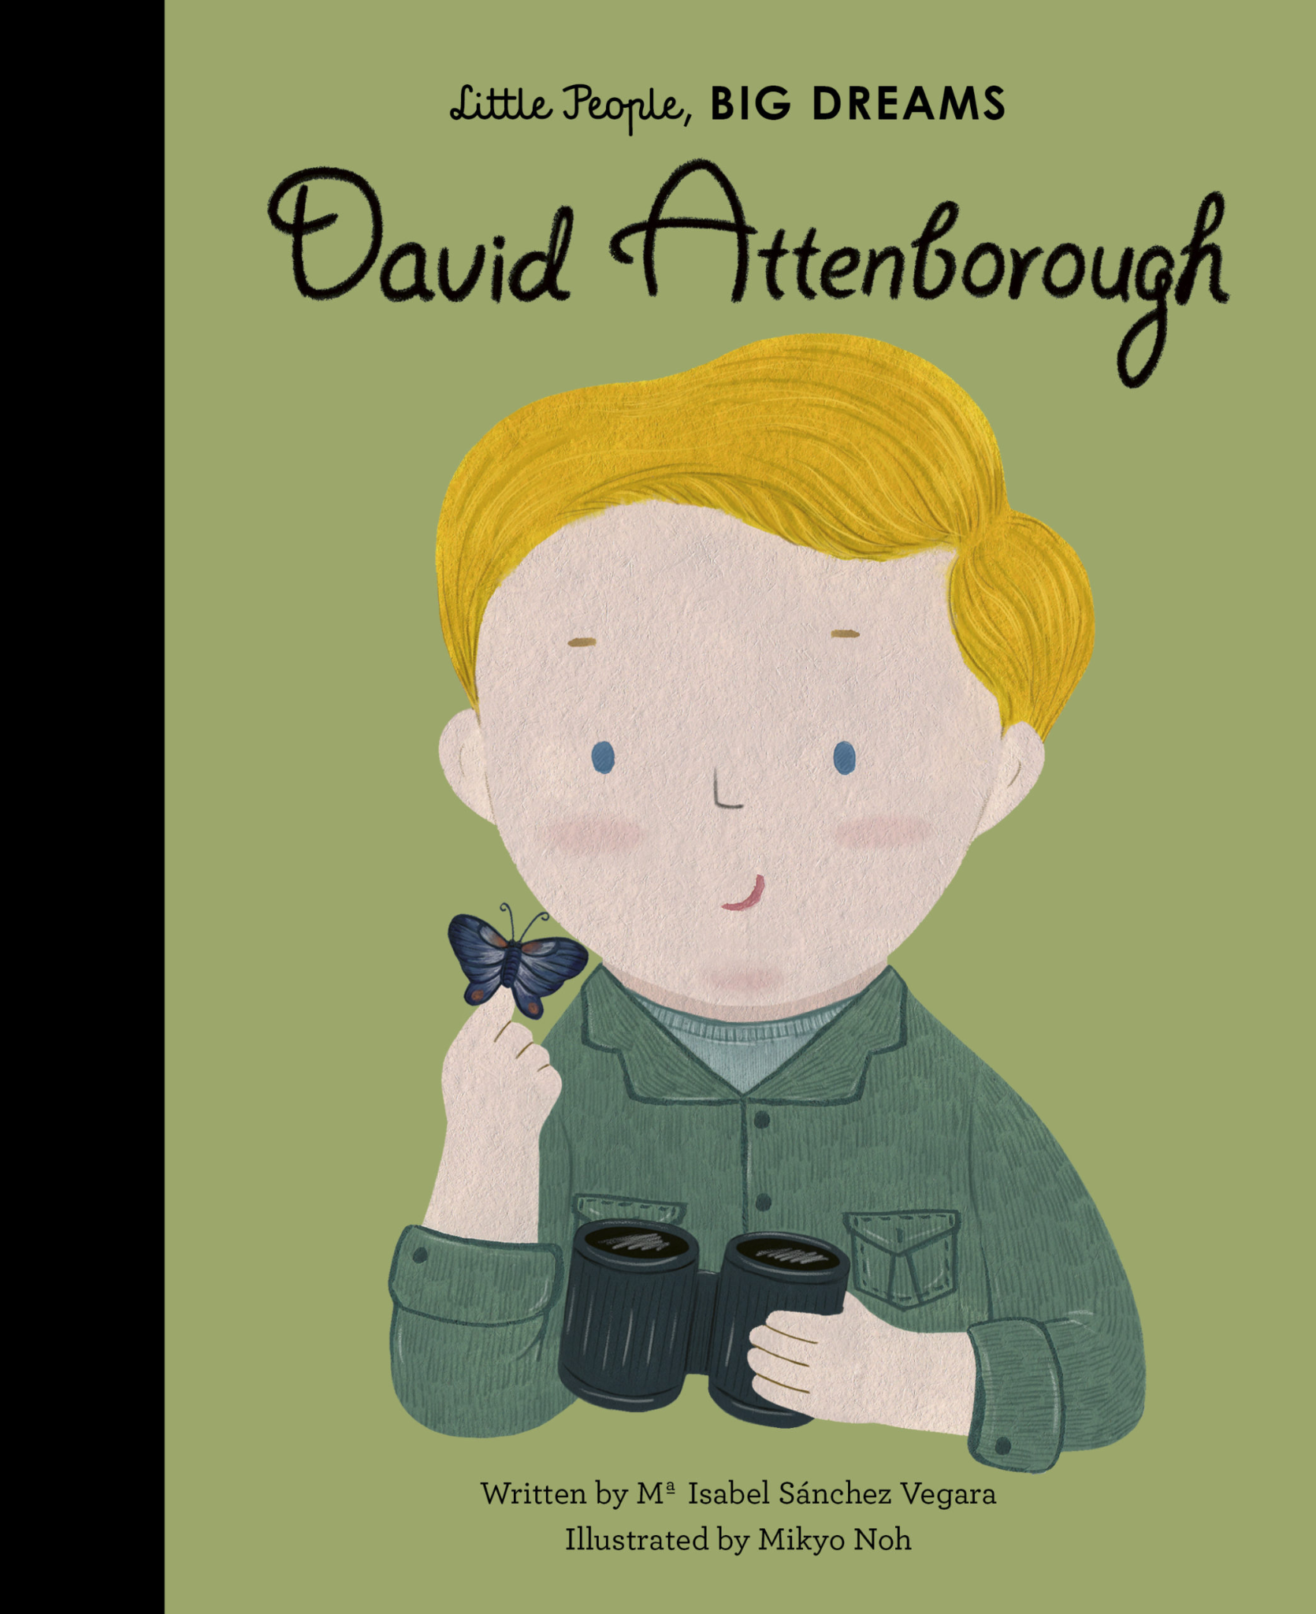  Explore how important David Attenborough has been for animal conservation | History  Transport in the past: Motor cars, steam trains, tall ships.  Look at images of ‘old fashioned’ cars and aeroplanes and discuss how they look different today.  Road safety- Maps help us to find out where we need to go. We can plan routes on a map.  Science  Forces  Ramps
 | Identify patterns in daily and seasonal weather.
Expressive Art and Design | Exploring percussion instruments  Self-portraits – painting of themselves for class display (belonging)  Picasso mash-up - We are all works of art  Mixing secondary colours | Artist focus - David Abbey Paige  Cutting: snowflake design  Explore musical instruments with a wintery sound such as bells, triangles and glockenspiels  Winter themed collages, using blue and white materials  Firework pictures | Creating our own super-hero mask  Create our own Supertato  Superhero city scape (collage and mark making) | Design and make a house  Making a Gingerbread Man  Explore different materials  Collage ball gown for Cinderella  Weaving a basket for Little Red Riding Hood | Water colours  Colour mixing  Matisse inspired collages  Henri Roussea inspired art/paintings | Design and make – junk modelling  Design: making a boat that floats and another vehicle that moves with wheels
Nursery rhymes: | Nursery rhymes:  Head, shoulders, knees and toes  If you’re happy and you know it clap your hands  Clap your hands and wiggle your fingers  Harvest songs | Frozen - Let it go, Do you want to build a snowman  Twinkle, twinkle little star  Her we go around the mulberry bush  Christmas songs/Nativity | I’m a little bean  There is a hungry caterpillar  One potato 2 potato 3 potato more...  Easter songs | Traditional nursey rhymes  -Charnaga | 5 little monkeys  Old McDonald  Once I caught a fish alive  Itsy Bitsy Spider  Mary had a little lamb  Charanga | Row, row, row your boat  The wheels on the bus  Ten little men in a flying saucer  Charanga
Festivals | Harvest Festival  Sukkot 7th-13th October | Diwali 20th October  Guy Fawkes  Remembrance Sunday  Hannukah 15th-22nd November  St Andrews day 30th November  Advent  Christmas  Anti bullying week WB 10th November  Children in need 20th November | Ramadan starts 1th February- 18th March  Chinese New Year 17th February  Shrove Tuesday 17th February | Passover 1st-9th April  St George’s Day 23rd April  St David’s Day 1st March  Holi 4th March  Mothers Day 15th March  St Patrick’s Day 17th March  Easter 5th April | May Day  Endangered species day 15th May | World Environment Day 5th June  World Ocean Day 9th June  King's Official Birthday 20th June Father’s Day 21st June
RE | Why is the word ‘God’ so important to Christians?  CREATION 1  A Muslim whispering Allah in a baby’s ear | Why do Christians perform nativity plays at Christmas?  INCARNATION 1  A Muslim story: Muhammad and the Ant | How can we help others when they need it?  SALVATION 2  A Sikh story: Har Gobind and the 52 Princes | Why do Christians put a cross in an Easter garden?  SALVATION 1  A Buddhist story: The Monkey King | What makes every single person unique and precious?  INCARNATION 2  Hindus celebrating at Raksha Bandhan | How can we care for our wonderful world?  CREATION 2  Tu be Shevat: the Jewish ‘Birthday of Trees’

