ROLL THE DICE AND WRITE THE WORD! HOW MANY WORDS CAN YOU WRITE IN TEN MINUTES?
1
2
3
4
5
6 |  |  |  |  |  |  | 
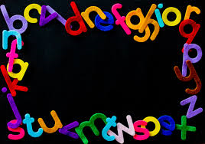
4
ROLL A TRICKY WORD

