SEND Support
This is a list of information websites, tips and resources to help you support your children with their additional needs, learning and self-esteem. Children have varying needs and there is no one size approach fits all. It is quite common for children to have additional needs that span all these areas, so select the resources that meet the needs of your child, without worrying too much about the label or category they fall under. Everyone has strengths and weaknesses and these SEND strategies will be beneficial to many children, whether or not they have a diagnosis.
ASD
Information Websites | https://www.autism.org.uk/  https://www.autism.org.uk/about/family-life/parents-carers.aspx
Tips | - Children with Autism need structure and routine. You can help them by using visual timetables to help them see what is happening at each step of the day, so they know in advance what they will be doing next. This will relieve some of their anxiety.  - You might want to set a specific place for them to do any work or tasks. At school they may have this in the form of a workstation to support their learning (see example in resources section). Each child’s workstation may differ slightly, so you could ask your child to help you set one up that will suit them or that they are already used to.  - Prepare them for changes in routine.  - Help your children to recognise and name different emotions and feelings. You can do this by discussing their own emotions, how characters in books and on TV programmes might be feeling and how you yourselves might be feeling. Alongside naming the emotion, describe it and explain why you, they or fictional characters might be feeling like that. You can also play role play guessing games and ask them to name the emotion and say why.  - Use a 5 point scale to support children in managing their emotions.  - Use social stories and comic strip cartoons to help children understand different situations and perspectives and address inappropriate behaviour.  - Have a visual aid to support wanted and unwanted behaviours (see School Website for examples).  - Be aware of your child’s sensory needs and support them in managing that need to help them learn e.g. sound reducing earphones if noise is a problem, comfortable clothes, keep the area surrounding the work space clear to avoid over-stimulation etc.  - Play lots of games with your child to encourage social skills, such as taking turns and winning and losing.
Resources | Visual timetable (see school website)  Social stories and comic strip cartoons: https://www.autism.org.uk/about/strategies/social-stories-comic-strips.aspx  5 point scale: https://www.5pointscale.com/  Social skills games: https://www.twinkl.co.uk/resources/specialeducationalneeds-sen/specialeducationalneeds-sen-social-emotional-and-mental-health-difficulties/sen-friendship-and-social-skills  http://autismteachingstrategies.com/free-social-skills-downloads-2/  Example of how a workstation works: https://www.google.com/search?q=asd+workstation&rlz=1C1GCEA_enGB768GB768&oq=ASD+workstation&aqs=chrome.0.0l2j69i59j0l2.3665j0j8&sourceid=chrome&ie=UTF-8#kpvalbx=__px4XpK-ONCQ8gKs24egBA49
ADHD
Information Websites | https://www.adhdfoundation.org.uk/information/parents/  General Info on ADHD - http://www.adders.org/info170.htm  Self esteem - http://www.adders.org/info79.htm  Managing ADHD - http://www.adders.org/info58.htm
Tips | - Offer routines and structure  - Create a quiet space for them to learn with no distractions.  - Give them something to fiddle with whilst you are talking to them or you want them to focus. It can also be helpful to let them move around whilst they listen.  - Ask them to do one task at a time  - Provide checklists or visual timetables to support organisation.  - Use timers to help with time management and build in frequent movement breaks.  - Suggest rather than criticise (children with ADHD often have low self-esteem)  - Provide lots of opportunities for exercise and movement.  - Set up a reward scheme to encourage them and support them with their behaviour.  - Build on success and help children to pursue more of what they enjoy.  - Put clear boundaries in place.
Resources | https://www.thebodycoach.com/blog/pe-with-joe-1254.html  Play games on consoles such as just dance, Wii Sports etc. to get your kids moving
Dyslexia
Information Websites | https://www.bdadyslexia.org.uk/advice/children/how-can-i-support-my-child  https://www.understood.org/en/school-learning/learning-at-home/homework-study-skills/8-working-memory-boosters
Tips | - It is important to encourage children to recognise and pursue the areas in which they excel (do more of what they enjoy) and support them with the areas they find difficult.  -Allow children to use a word processer to complete some written tasks. This highlights spelling errors and offers alternatives. If they can’t type, encourage them to learn, so that they are able to use a Word Processer with more speed and fluency.  -Play games to support memory and retention e.g. pairs, Go Fish etc. (see resource links for more ideas)  -Enable children to access age related audiobooks to develop a love of reading. Encourage (don’t force or push) them to share what’s happening in the story and share their excitement, wondering aloud what will happen next. This will also develop their vocabulary and comprehension, without them even realising that they are learning.  -Don’t make reading a fight. Encourage children to read one page and you read the next page. Read some books to them for pleasure and invite them to read a section if they want to (don’t push if they don’t want to). By developing a love of books and stories children will naturally want to learn how to read, so make the experience as pleasurable as you can.  -Try using paired reading (see attached guidance) – there is evidence that this can be helpful in supporting learners  -Audio books are also helpful for developing vocabulary and enjoyment - Audible are offering free access to some of their children’s books while schools are closed. https://stories.audible.com/start-listen  -These apps can also be helpful for practising spelling and reading at home  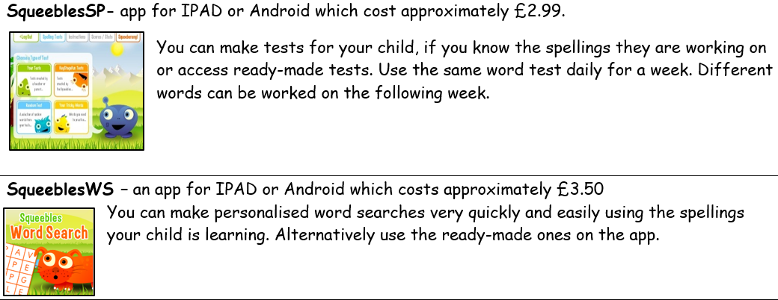
Resources | Dancemat Typing – free beginners typing course for children. https://www.bbc.co.uk/bitesize/topics/zf2f9j6/articles/z3c6tfr  Free Phonics games - https://www.phonicsplay.co.uk/  https://www.weareteachers.com/working-memory/  https://www.understood.org/en/school-learning/learning-at-home/homework-study-skills/8-working-memory-boosters  Free audio stories https://stories.audible.com/start-listen
Motor Coordination Disorder/Dyspraxia
Information Websites | https://dyspraxiafoundation.org.uk/  http://www.movementmattersuk.org/
Tips | - Allow children to use a word processer to complete some written tasks if you feel this is appropriate. If they can’t type, encourage them to learn, so that they are able to use a Word Processer with more speed and fluency.  - Offer routines and structure  - Create a quiet space for them to learn with no distractions.  - Give them something to fiddle with whilst you are talking to them or you want them to focus. It can also be helpful to let them move around whilst they listen.  - Ask them to do one task at a time  - Provide checklists or visual timetables to support organisation.  - Use timers to help with time management and build in frequent movement breaks.  - Play lots of games with your child to encourage social skills, such as taking turns and winning and losing.  - Help your children develop their fine and gross motor skills and core stability (see resource below)  https://dyspraxiafoundation.org.uk/wp-content/uploads/2013/10/classroomguidelines.pdf
Resources | Dancemat Typing – free beginners typing course for children. https://www.bbc.co.uk/bitesize/topics/zf2f9j6/articles/z3c6tfr  Motor skills development: https://www.lincolnshirecommunityhealthservices.nhs.uk/application/files/2915/2285/5110/1st_Move.pdf  Visual timetable (see school website)  Social stories and comic strip cartoons: https://www.autism.org.uk/about/strategies/social-stories-comic-strips.aspx  5 point scale: https://www.5pointscale.com/  Social skills games: https://www.twinkl.co.uk/resources/specialeducationalneeds-sen/specialeducationalneeds-sen-social-emotional-and-mental-health-difficulties/sen-friendship-and-social-skills
Dyscalculia
Information Websites | https://www.sess.ie/categories/specific-learning-disabilities/dyscalculia/tips-learning-and-teaching  https://www.bdadyslexia.org.uk/dyslexia/neurodiversity-and-co-occurring-differences/dyscalculia-and-maths-difficulties
Tips | - Concentrate on one problem at a time.  - Use lots of visuals and physical resources that the children can move around.  - Include children in supporting you with everyday maths problems e.g. cooking, measuring, money etc.  https://blog.brainbalancecenters.com/2016/02/5-strategies-for-managing-dyscalculia  https://www.understood.org/en/school-learning/partnering-with-childs-school/instructional-strategies/at-a-glance-classroom-accommodations-for-dyscalculia
Resources | https://whiterosemaths.com/homelearning/  https://www.10ticks.co.uk/
Speech and Language
Information Websites | https://www.hct.nhs.uk/our-services/childrens-speech-and-language-therapy/  https://www.thecommunicationtrust.org.uk/
Tips | Speech sounds  - Model speech to the children by repeating words back to them correctly.  Understanding:  - Give children time to process what you have asked and respond.  - Use simple language and break instructions down into smaller steps.  - Encourage children to answer questions, such as who, what, where, when and why? When reading their books. Encourage them to tell you the story in their own words.  Expression  - Talk about all your experiences in detail, teaching new vocabulary all the time.  - Discuss vocabulary in books, making sure the children understand the meaning of tricky words.  Social Communication  - Play lots of games with your child to encourage social skills, such as taking turns and winning and losing.  - Use a visual timetable and visual aids to provide structure and routines.  - Talk about emotions, what they are, what they look like on people’s faces etc.
Resources | https://www.thecommunicationtrust.org.uk/  Continue to work on Speech and Language targets set by the Speech and Language Therapist (if already seen).  https://www.thecommunicationtrust.org.uk/resources/resources/resources-for-parents/  Social skills games: https://www.twinkl.co.uk/resources/specialeducationalneeds-sen/specialeducationalneeds-sen-social-emotional-and-mental-health-difficulties/sen-friendship-and-social-skills  http://autismteachingstrategies.com/free-social-skills-downloads-2/
Emotional Wellbeing
Tips | This can be a challenging time for children and changes in routine can cause distress and anxiety. It is important for children who find this challenging to be able to predict what is happening next and a visual timetable will be good for this.  It is also important to build in time for mindfulness and brain breaks throughout the time, this might be colouring, playdough, some exercise or an activity of your child’s choosing.
Resources/Websites | There are audiobooks to support stress and anxiety on Borrow Box -these might be best listened to together so your child can share their worries with you https://fe.bolindadigital.com/wldcs_bol_fo/b2i/search.html?b2bSite=5970&searchBy=ALL&q=teen  Build in exercise regularly!! – There are free PE lessons from Joe Wicks on Youtube each day. Go to The Body Coach TV on YouTube and join in the 30-minute workout session from 9am Monday to Friday.  -https://www.mind.org.uk/information-support/coronavirus-and-your-wellbeing/  https://www.mentalhealth.org.uk/publications/looking-after-your-mental-health-during-coronavirus-outbreak  https://www.healthyyoungmindsinherts.org.uk/parents-and-carers  https://youngminds.org.uk/

