Supporting your child with maths difficulties at home

Games and Activities:
This is a really positive opportunity to play a range of games with your children at home to extend and secure their maths understanding. By playing games many times, your child will have the chance to master lots of basic maths concepts in a fun and enjoyable way. For example:
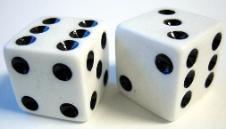
Any games involving dice, for example, Snakes and ladders, Ludo, Yahtzee
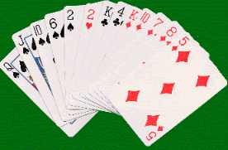
Card games, for example, Pairs, Patience,
Number Snap (saying each number out
loud), Dominoes.

Games involving money – Orchard shopping games, role-play shops, Monopoly.
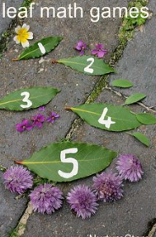
Cooking with your child – weighing ingredients, measuring amounts etc.

For free ideas of number activities to support various areas of maths including number formation, counting, sequencing etc, visit this website: https://www.pinterest.co.uk/SpTeachersLDD/maths/

Basic Number Facts:
Have a look at our leaflet on supporting basic number facts – you will find lots of ideas to support your children at home… https://www.hertfordshire.gov.uk/microsites/local-offer/media-library/documents/resource-area-documents/spld-maths-basic-number-facts-booklet.pdf
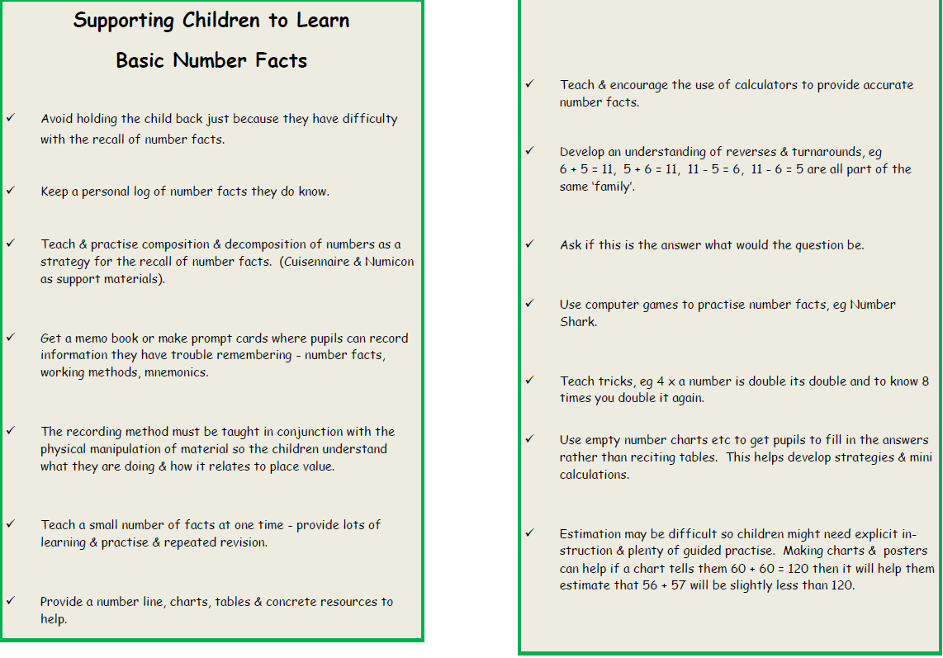

Maths Resources:
For free maths resources for all age groups, visit:
https://www.atm.org.uk/Free-ATM-Resources- (recommended by the NCETM – National Centre for Excellence in the Teaching of Mathematics)
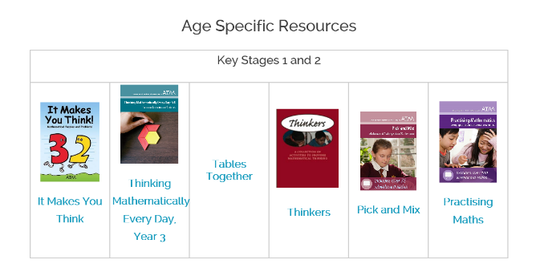

More fun games are available at the following website. This website is a really good way to help you to explain some basic maths concepts to your children.
https://www.mathsisfun.com/games/index.html
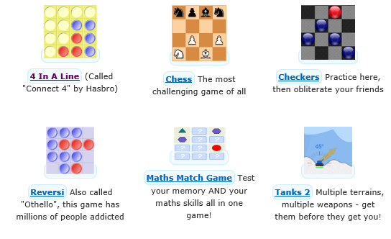

Free educational games aimed at primary children.

http://www.ictgames.com/

