Nursery Curriculum Overview
 | Autumn 1 | Autumn 2 | Spring 1 | Spring 2 | Summer 1 | Summer 2
 | I am special -Being Me In My World | Let’s Celebrate | Adventures at sea! | Let’s Grow | We are going on a journey | Animal Kingdom
 | My family, my school, my environment, the people around me, | My community, my beliefs, respecting others, traditions, cultures, food, celebrations. | Life at sea, pirates, maps, ocean creatures, caring for our environment | Spring, new life, life cycles, plants, seeds, bulbs, plants we can eat, how people grow | Places we visit, ways to travel including walking, cars, buses, trains, aeroplanes, faraway places including the coldest places on earth | Animals and their offspring, farm animals, woodland animals, wild animals, animals who live in the coldest/hottest places on earth.
Literacy and suggested text  Taught alongside systematic phonics | 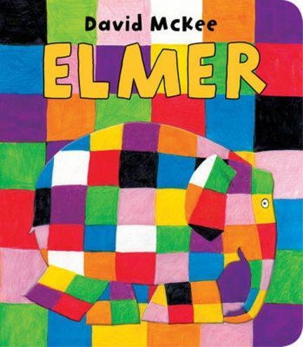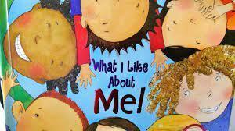  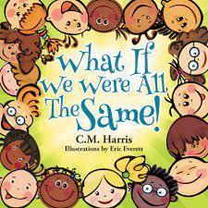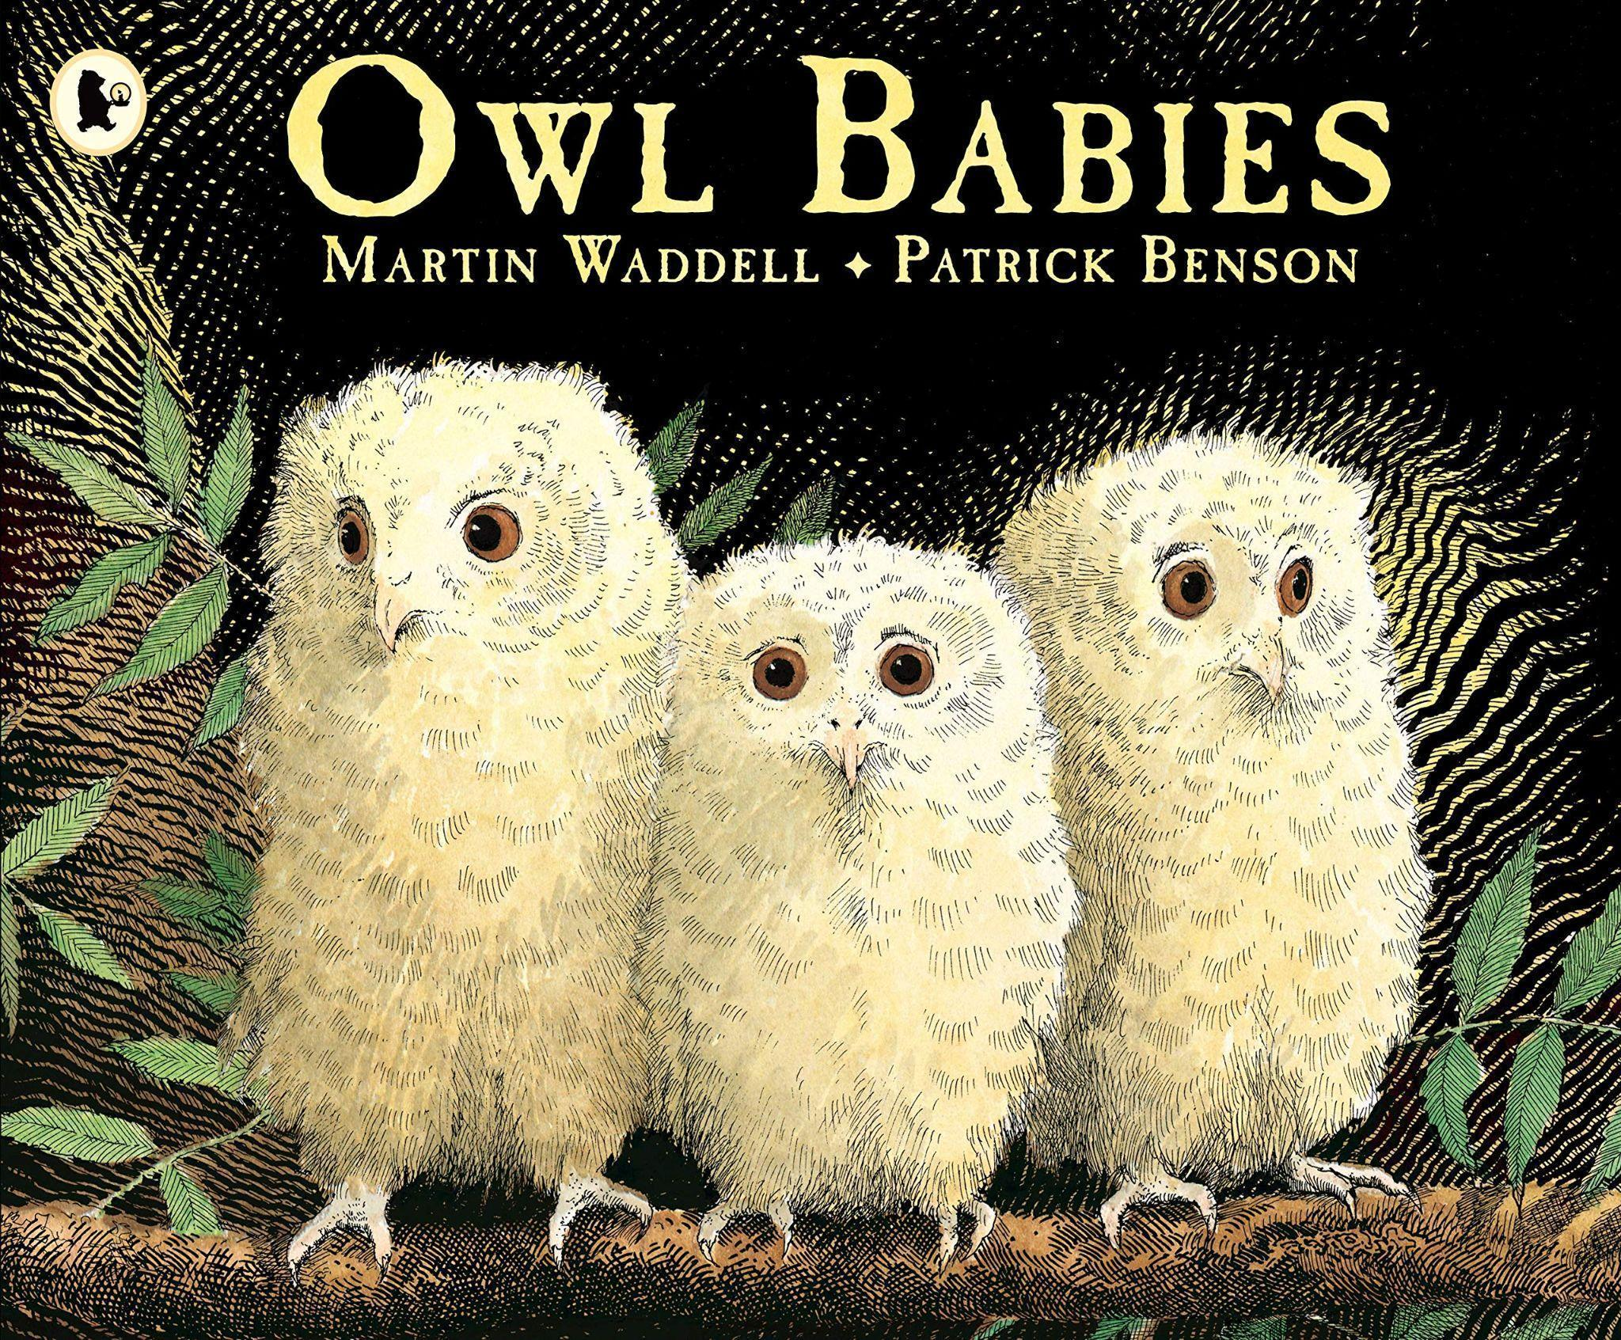 | 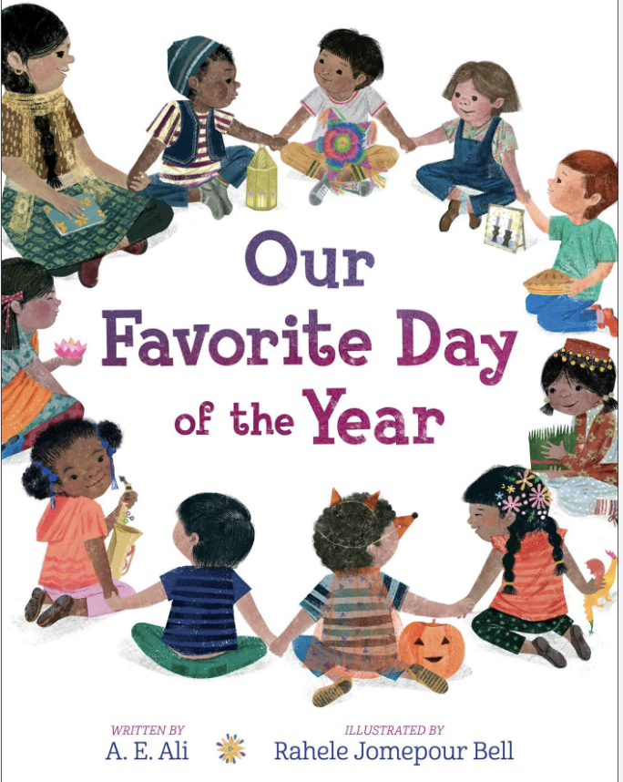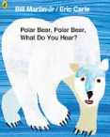  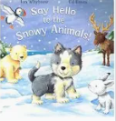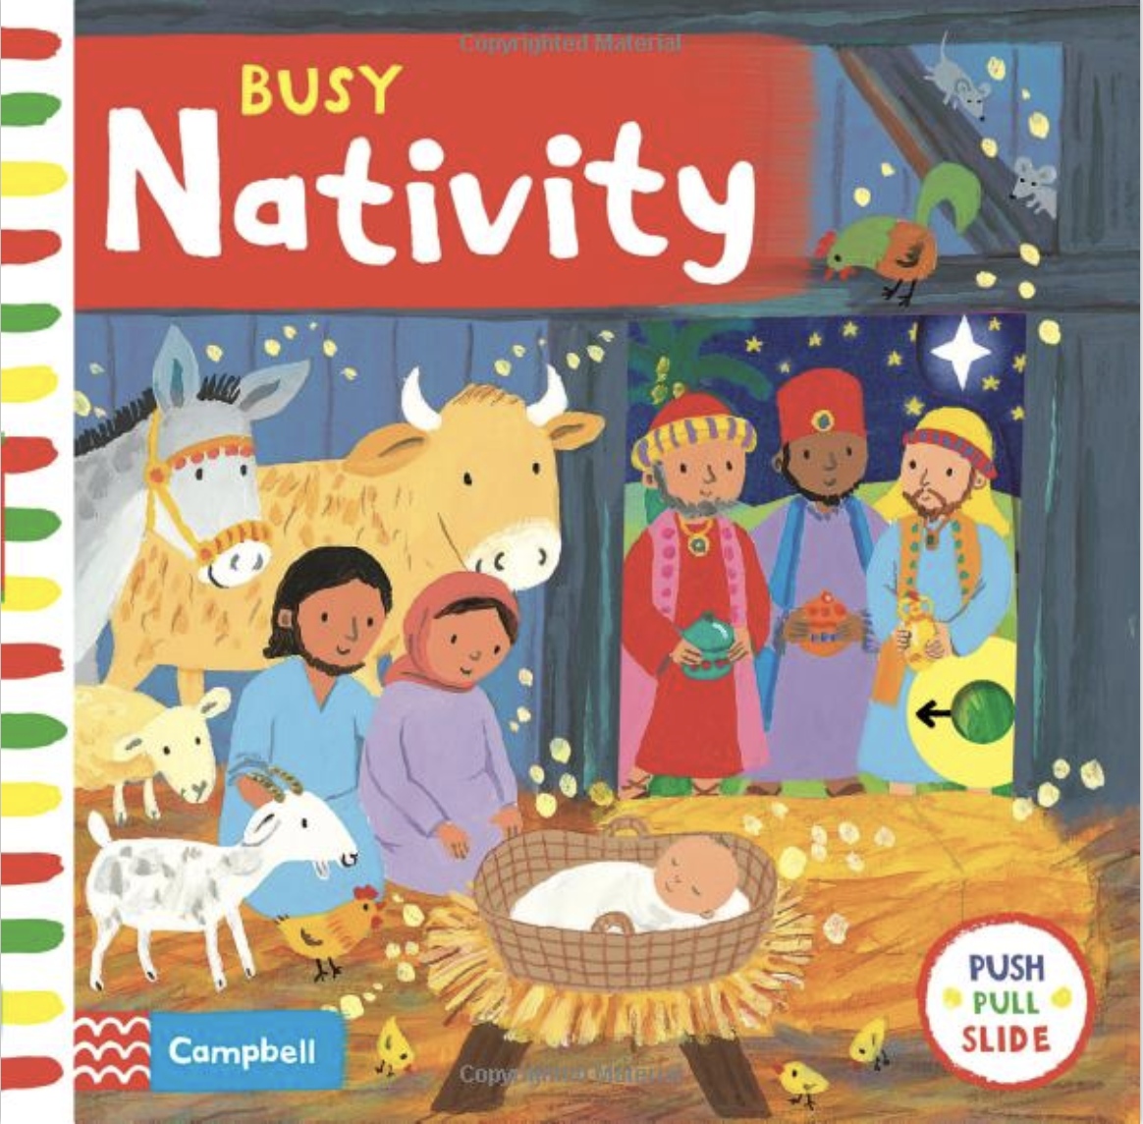 | 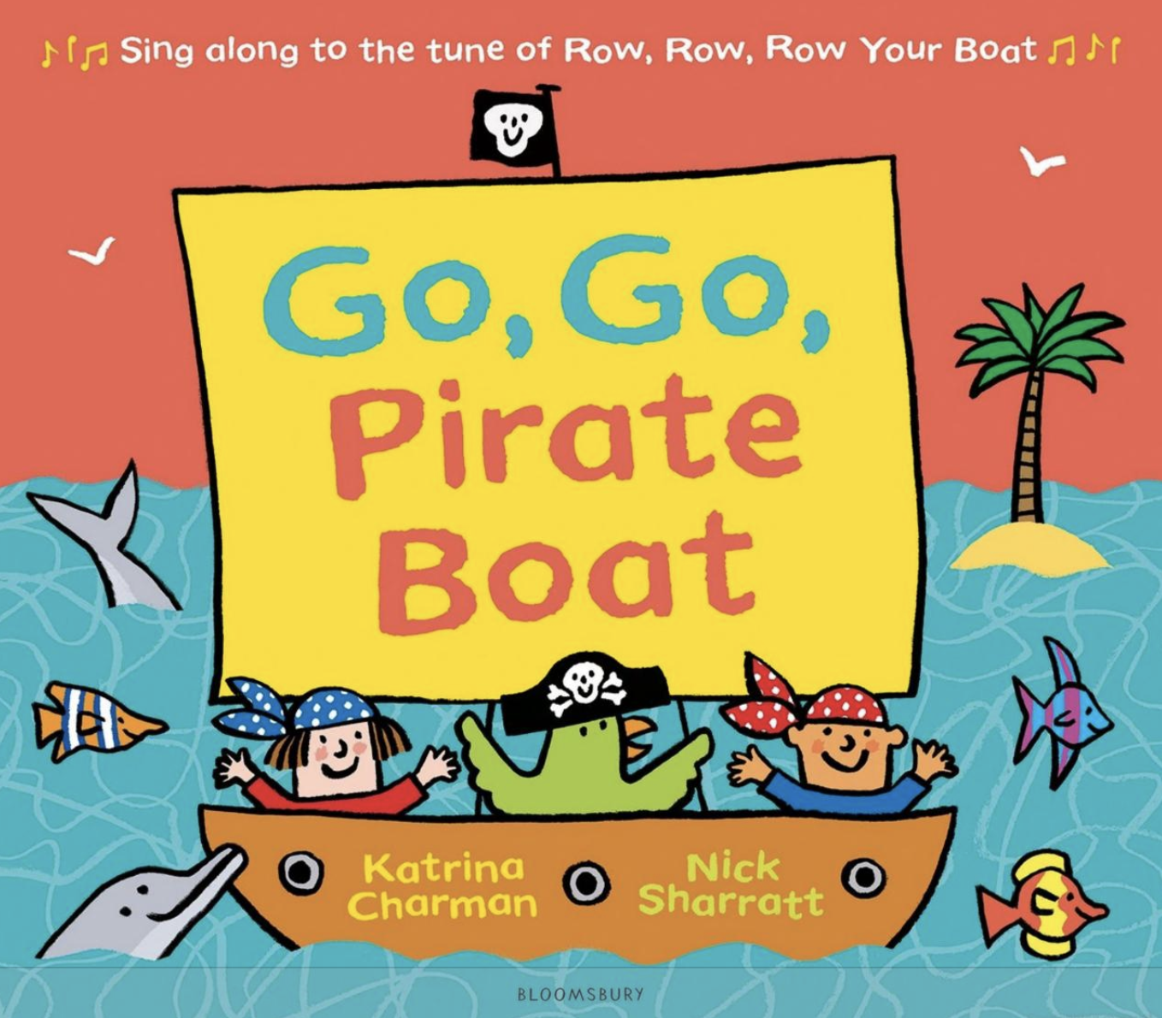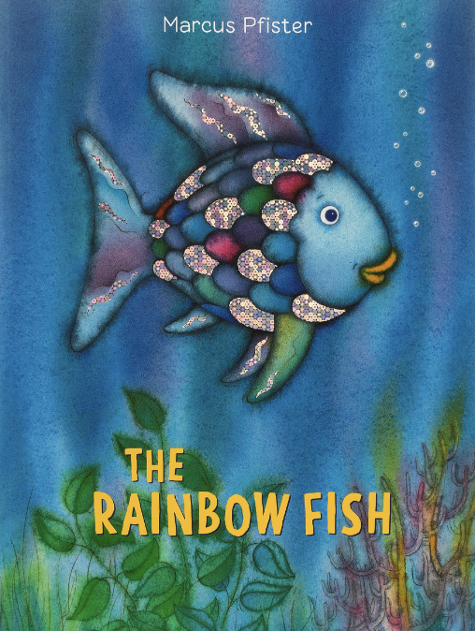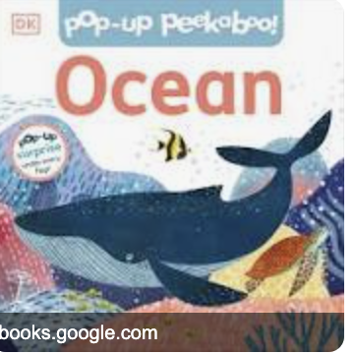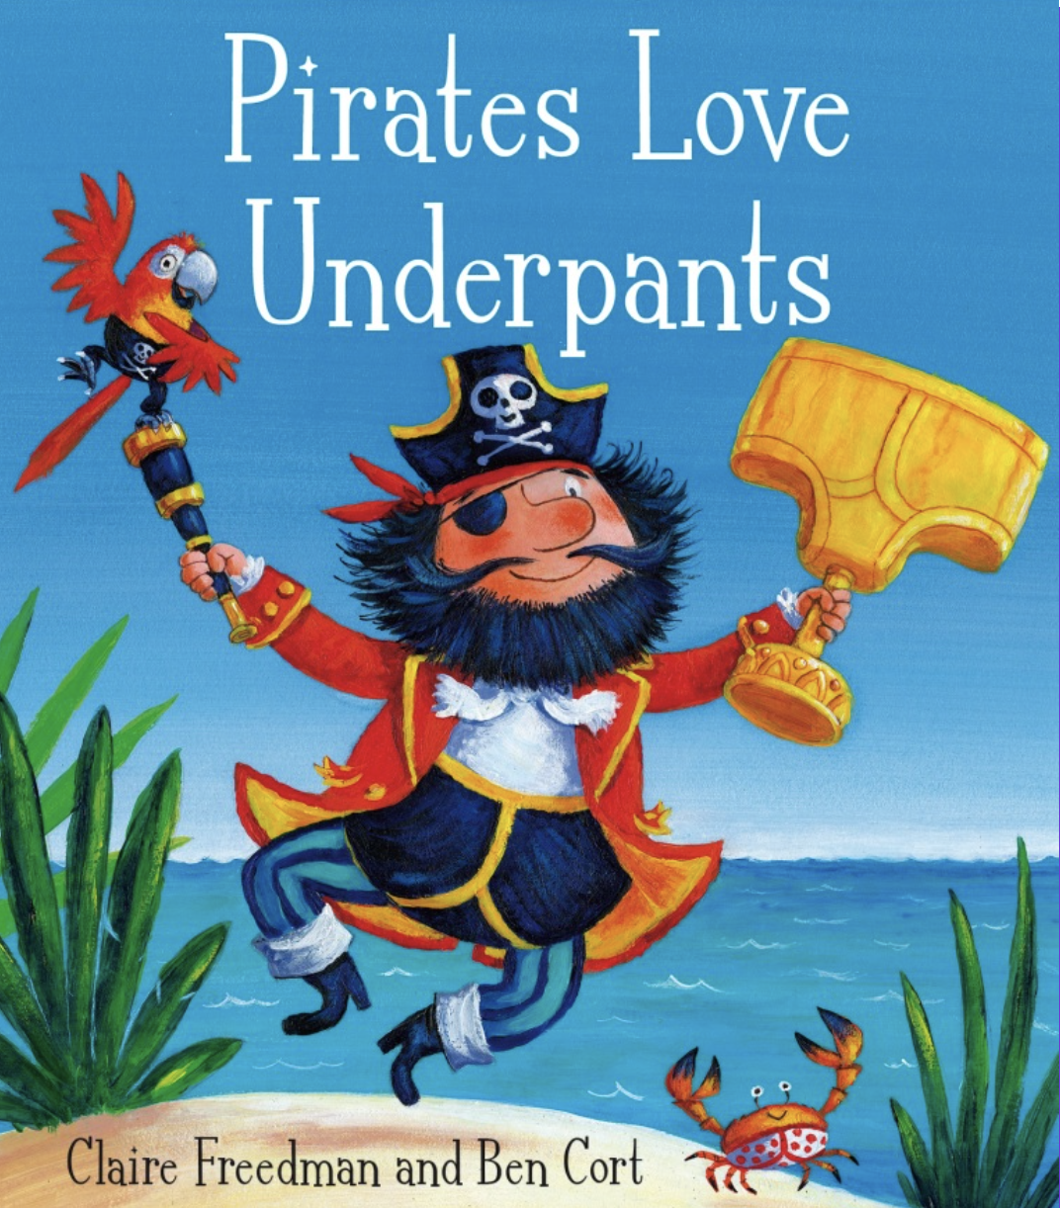 | 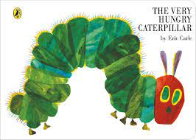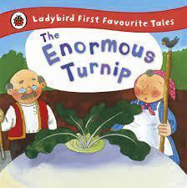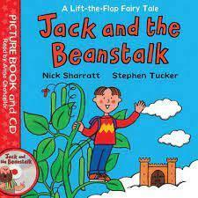 | 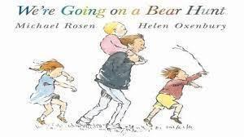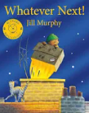  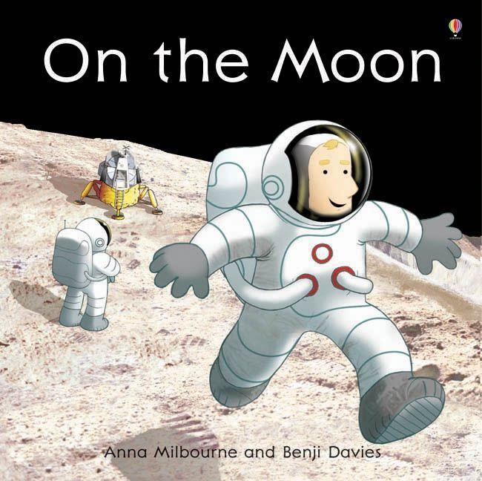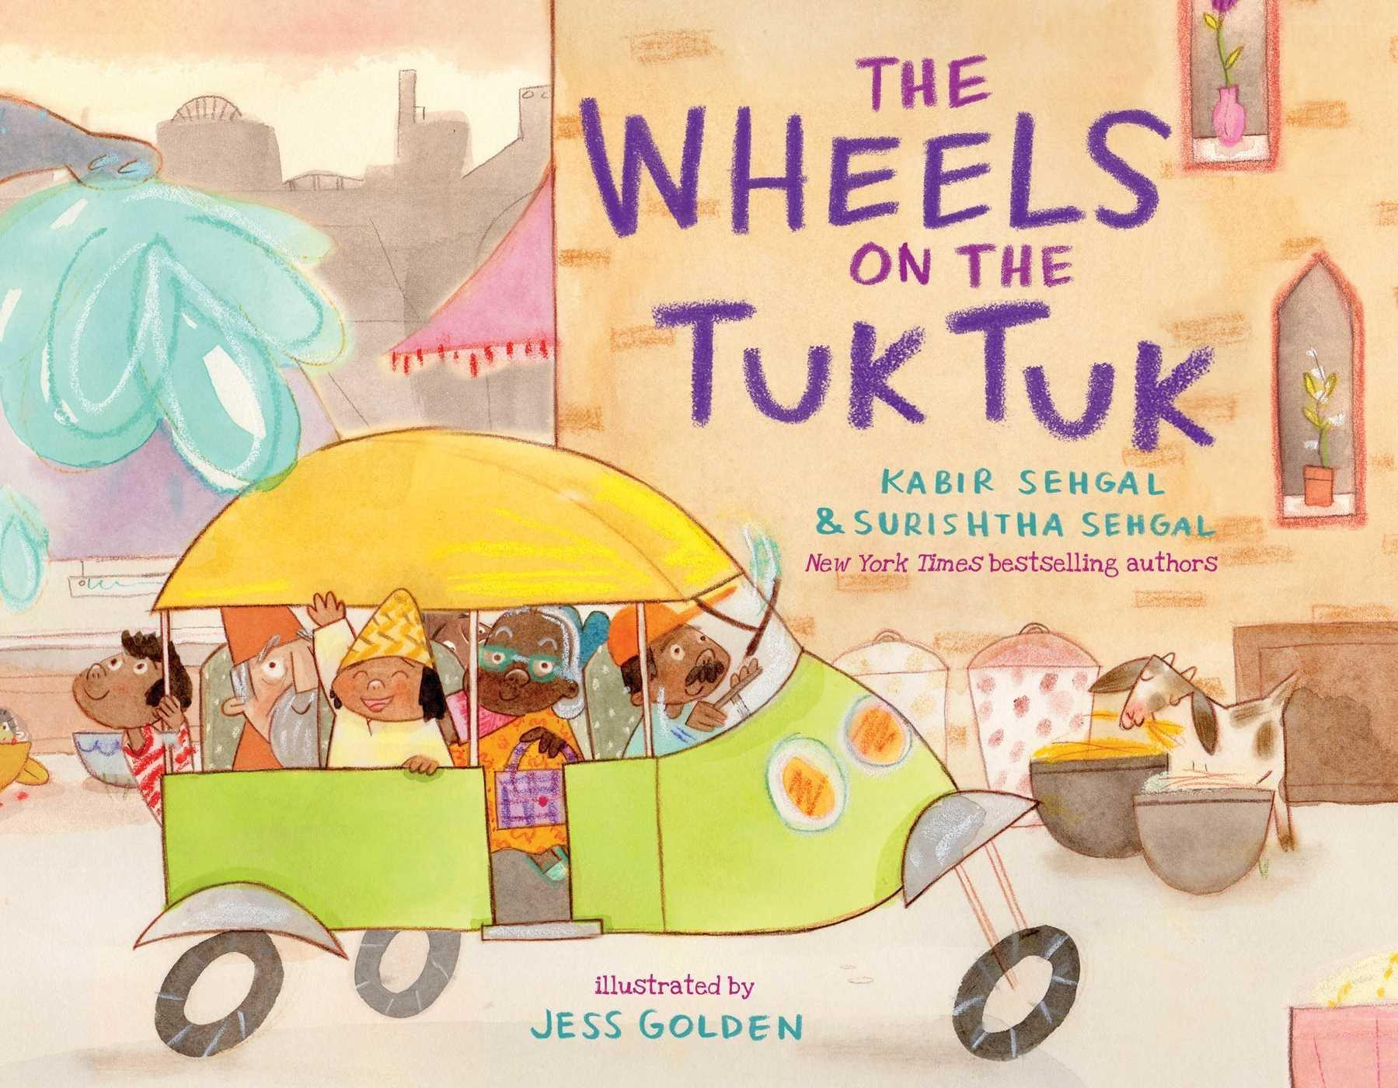 | 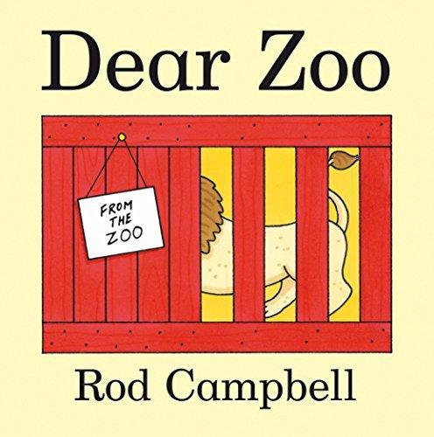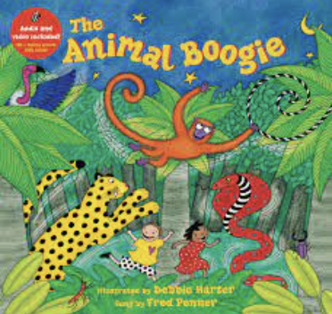  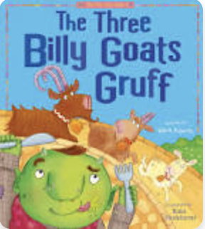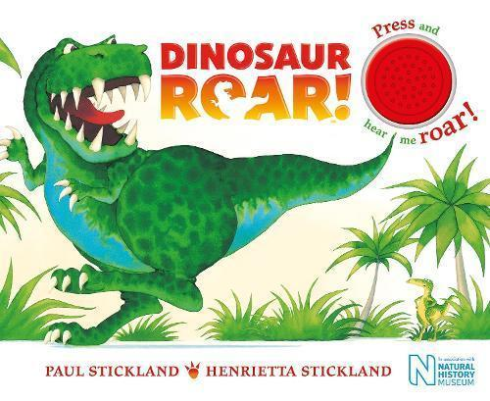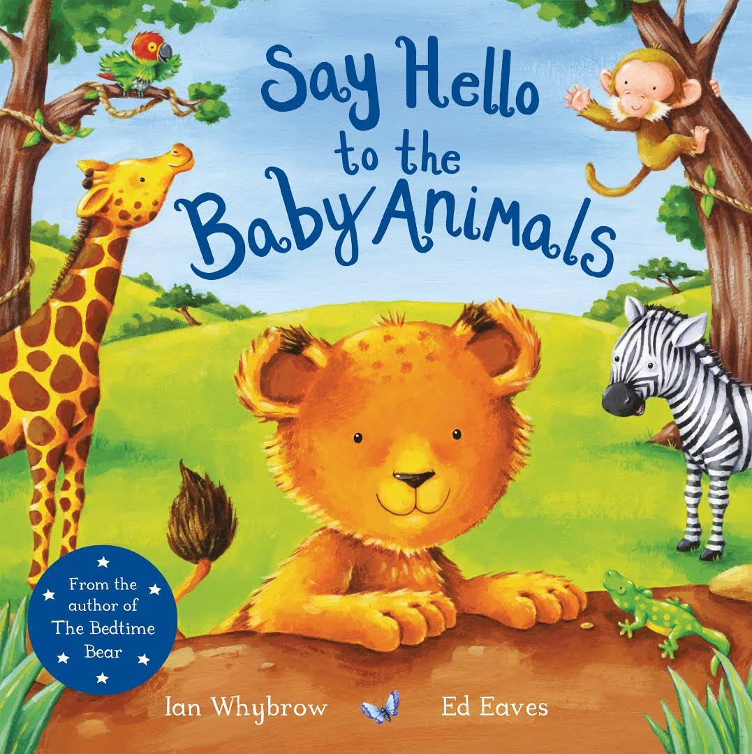
Communication & Language | Enjoy listening to longer stories.  Pay attention to more than one thing at a time.  Understand a question or instruction that has two parts, such as: “Get your coat and wait at the door”.  Sing a large repertoire of songs.  Know many rhymes,  Be able to talk about familiar books, | Listening to others in small groups. Understand ‘why’ questions, like: how did the baby animals feel? Why did the shepherds visit Bethlehem?  Sing a growing repertoire of songs. Know an increasing number of rhymes.  Show and tell  Joey the book | Develop their communication skills and begin to use more complex sentences to link thoughts.  Use a wider range of vocabulary linked to our topic.  Develop their pronunciation of words. | Use longer sentences of four to six words. Talk about familiar books, and be able to tell a long story. Follow simple directions on how to plant a seed.  Understand ‘why’ questions, like: “Why do you think the caterpillar got so fat?”  Apply new vocabulary to explain changes noticed in plants. E.g. This plant did not grow well because the soil was too dry. | Use vocabulary from recently read stories in conversations e.g. different ways of travel  Ask questions using what, where, when and why to find out more about journeys. | Recognise and use the following vocabulary:  Farm Animals: cow/calf, pig/piglet, sheep/lamb,  Build up vocabulary that reflects knowledge and experience e.g. talking about dinosaurs, that they lived along time ago, their names and features etc.  Ask relevant questions  Share opinions, explaining preferences e.g. My favourite dinosaur is… because…
Physical  Gross | Spatial awareness and multi-step instruction games  Running, jumping, in a large space.  Go up steps, or climb up apparatus using alternate feet.  Dance to music | Spatial awareness and coordination games  Obstacle courses using large apparatus  Skip, hop, stand on one leg and hold a pose for a game like musical statues. | Gymnastics activities  Using large muscle movements to wave flags and streamers, paint and make marks.  To be able to use and remember sequences and patterns of movements which are related to music and rhyme.  Balance- standing on one leg, walking along a bench, climbing  Football  Throwing and catching | Hula hoops, skipping games and ball games.  Jumping  Team games  Tunnels and obstacle course | Team games and ball skills  Running, jumping, hopping from foot to foot  Invasion games and basic movement skills | Athletic activities links to Sports day  Start taking part in some group activities which they make up for themselves, or in teams.  Continue to develop their movement, balancing, riding and ball skills.  Match their developing physical skills to tasks and activities in the setting. For example, they decide whether to crawl, walk or run across a plank depending on its length and width.
Physical  Fine | Using fine motor resources such as pegs and playdough  Drawing my family and self portraits  Pencil grip when name writing  Be increasingly independent as they get dressed and undressed, for example, putting coats on and doing up zips. | Using fine motor resources such as threading, using pipe cleaners and playdough and tools.  Pencil grip  Be increasingly independent as they get dressed and undressed, for example, putting coats on and doing up zips. | Small tools; cutlery, tweezers, pipettes, scissors  Pencil grip  Be increasingly independent as they get dressed and undressed, for example, putting coats on and doing up zips. | Small tools; cutlery, tweezers, pipettes, scissors  Pencil grip  Show a preference for a dominant hand  Name writing | Small tools; cutlery, tweezers, pipettes, scissors  Pencil grip  Show a preference for a dominant hand  Name writing | Small tools; cutlery, tweezers, pipettes, scissors  Pencil grip  Show a preference for a dominant hand  Name writing
Personal, social and Emotional Development | Being Me - How can I manage my feelings?  Explain the classroom and school rules.  Form friendships within my class.  Understanding the routines and boundaries of the nursery setting.  Consider routines and patterns of a typical day  Celebrating Difference  How are we different?  Identifying talents  Being special  Making friends  Be increasingly independent in meeting their own care needs, e.g. brushing teeth, using the toilet, washing and drying their hands thoroughly. | Talk about the different feelings in relation to the core books.  Share the importance of turn taking.  Take part in turn taking games in small groups  Be increasingly independent in meeting their own care needs, e.g. brushing teeth, using the toilet, washing and drying their hands thoroughly. | Seeking help from adults and peers  Dreams and Goals  Achieving goals  Be increasingly independent in meeting their own care needs, e.g. brushing teeth, using the toilet, washing and drying their hands thoroughly. | Healthy me  What is being healthy?  Growing and Changing  Understand some areas in which the children can look after themselves e.g dressing  Be increasingly independent in meeting their own care needs, e.g. brushing teeth, using the toilet, washing and drying their hands thoroughly. | Changing me  When do my feelings change?  Challenges: moving to Reception  Jobs  Be increasingly independent in meeting their own care needs, e.g. brushing teeth, using the toilet, washing and drying their hands thoroughly.  Digital Me  Why do we have to be careful? | The World and Me  What is my place in the world?  How do we care for animals?  How can animals help us?  What are our favourite animals?  Showing confidence in asking adults for help.  Understanding feelings and how our actions can hurt others or make them feel good.  Challenges: moving to Reception  Be increasingly independent in meeting their own care needs, e.g. brushing teeth, using the toilet, washing and drying their hands thoroughly.
Literacy | Understand that print has meaning.  Develop their phonological awareness, so that they can: - spot and suggest rhymes.  Begin to engage in conversation about stories. | Understand that we read English text from left to right and from top to bottom.  Sensory mark marking  Recognise their own name | Understand that print can have different purposes,e.g. a shopping list, story, recipe, etc. Develop their phonological awareness so they can clap the syllables in words. Begin to write some of their name. | Identify and name the different parts of a book, e.g. front cover, pages, etc. Develop their phonological awareness to recognise words with the same initial sound, such as money and mother. Write some or all of their name. | Understand page sequencing. Recognise words with the same initial sound, such as money and mother. Engage in extended conversations about stories, learning new vocabulary. Write some or all of their name. | Use some of their print and letter knowledge in their early writing. For example: writing a pretend shopping list that starts at the top of the page; writing ‘m’ for mummy. Write some letters accurately.
Mathematics | Numbers 0 to 10- counting  Representing on fingers and other concrete counting  Show an interest in numbers and counting by engaging in daily chanting, counting objects and singing number songs and rhymes.  Name and recognise colours | Recognising numbers 0--10  Representing on fingers and other concrete counting (show me)  Link numerals to amounts.  Counting 0-5  Number formation (gross motor) with paint, with fingers in sand, with marbles running around number templates.  Notice patterns in the environment.  Continue a repeating pattern link to computing. | Recognising numbers 0-10  Introduce tens frame  Begin to represent numbers using fingers, marks on paper or pictures.  Identifying 2D shapes in the environment  Shapes for different tasks (block building) Combine | Counting up to and beyond 10  Explore properties of 2D shapes and  use appropriate terms to describe them.  Continue to solve problems using a range of strategies.  Make comparisons between objects relating to length.  Make comparisons between objects relating to capacity. | Increasingly confident to put numbers in order 10. To solve number problems using real objects.  Identifying 3D shapes in the environment and use mathematical language, sides, corners, straight, flat, round.  Select shapes appropriately flat surfaces for a building, a triangular prism for a roof.  Combine shapes to make new ones, an arch, a bigger triangle.  Describe a familiar route  Discuss routes and locations using words like in front of and behind - Positional language | Begin to compare two groups of objects, saying when they have the same number, more and fewer.  Subitise numbers to 5.  Make comparisons between objects relating to weight.  Begin to describe a sequence of events, real or fictional using words such as first, then, next.  Printing repeated patterns
Past and Present (History) | To be able to talk about his/her own life/personal history, i.e. what were they like as a baby/toddler  To have an understanding of their position in their own family and to be able to name and talk about older family members.  Family Trees (grand parents, great-grandparents)  When I was a baby  Developing a sense of chronology; before I was born, before I came to nursery, when I go to school. | Mary and Joseph’s journey to Bethlehem | Share past events such as holidays by the sea, visiting the seaside | Observing how natural things change over time | Building on basic understanding of chronology, look at old photos of the local area and think about how it has changed.  Transport in the past: Motor cars, steam trains, tall ships.  Look at images of ‘old fashioned’ cars and aeroplanes and discuss how they look different today.  Locally significant areas it e.g. a local historical building  We live on the Earth.  People want to explore space to find out more about it. (Neil Armstrong)  Show interest in different occupations. | Dinosaurs lived on our planet but they are now extinct.  Dinosaurs lived for a long time, some of them lived and died without ever meeting each other (Stegosaurus and T-Rex lived around 80 million years apart)  Show interest in different occupations.  Compare and contrast characters from stories, including figures from the past.
People, Culture and Communities (Geography) | Where I live  Where I was born  Where my family live  People who help us in our school and wider community (teachers, nurses, doctors, firefighters, police) | Continue developing positive attitudes about the differences between people.  Know that there are different countries in the world and talk about the differences they have experienced or seen in photos.  What do you celebrate?  Can you find the country on the map? | Locate oceans and seas on the map  Begin to understand the need to respect and care for the natural environment and all living things.  Talk about what they see using a wide vocabulary.  Maps help us to find out where we need to go. We can plan routes on a map  Draw information from a simple map. | Farming; what do farmers do? What do they grow? What crops grow near to where we live? What grows in our country that we can eat?  What kinds of plants grow in other countries? Where do bananas grow? Where do oranges grow?  Talk about our capital city of London | Types of transport; walk, bus, car, bicycle, scooter, taxi, train, plane, helicopter.  People; bus driver, car driver, taxi driver, train driver, pilot, astronaut.  How do we travel to: school, the shops, the beach, another countries, the moon?  Maps help us to find out where we need to go. We can plan routes on a map  Where do we live? - The Union Jack flag. | Dinosaur bones have been found all around the world, particularly in North America, China and Argentina. (Locate on map of world)  In England, many fossils have been found in Dorset along the Jurassic Coastline. (Locate on map of England)  Understand that fossils are left over parts of animals or plants that lived a very long time ago. People who learn about and search for dinosaurs and fossils are called palaeontologists.  Wild animals that live in other countries around  Learn that different animals live in different habitats, compare and contrast.
The Natural World (Science) | My body has many different parts  Our faces are all different.  The season of Autumn, leaves changing colour and falling from trees. | Explore light and dark.  Talk about the difference between materials and changes they notice. | Use all their senses in hands on exploration of natural materials  Begin to understand the need to respect and care for the natural environment and all living things.  The season of winter, bare trees, cold, frosty weather, ice | Grow ‘beanstalks’; plant and observe plants growing e.g. sunflowers, cress etc. Talk about how the plants change.  Make observations of the world around them, describe things they have seen e.g. plants, animals, natural objects and man-made objects.  Life cycles: caterpillars, tadpoles  The season of Spring, blossom, new growth, new leaves | Explore collections of materials with similar/or different properties.  Explore how things work.  Explore and talk about different forces they can feel.  Plan a journey to the local park, or around the school grounds. What would we see? What grows in our school, what grows in the park?  The season of Summer, flowers, plants, warm, hot weather | We know about dinosaurs because people have found fossils in the ground.  Rocks can sometimes contain fossils that palaeontologists can study.
Expressive Art and Design  Creating with materials  Being imaginative and expressive | Drawing  Portraits- self-portrait using chunky pens and paint  Draw with increasing complexity and detail, such as representing a face with a circle and including detail.  Children begin to explore colour and different textures.  Print making  Seasons: Leaf printing  Take part in simple pretend play.  Listen with increased attention to sounds. | Sculpture  Diwali pinch pot  Jackson Pollock  Focus on Primary colours: Mixing colours fireworks paintings  Marbles  Explore colour and colour mixing.  Use drawing to represent ideas like movement or loud noises.  Christmas craft  Christmas cards  Christmas nativity and Christmas songs | Sculpture  Ocean in a box  Take part in simple pretend play, using an object to represent something else even though they are not similar.  Listen with increasing attention to sounds- musical instruments  Collage  Rainbow Fish collage | Painting  Draw and paint sunflower  link to Van Gogh  Printing with flowers  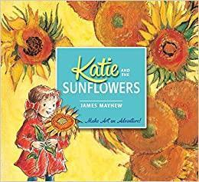  Create closed shapes with continuous lines and begin to use these shapes to represent objects.  Show different emotions in their drawings and paintings like happiness, sadness and fear.  Easter baskets and nests | Design and make  Dance and movement showing different ways to journey across the floor  Design and make a boats and sails using recycled pots  - yoghurts  - butter  - fruit packaging  Develop their own ideas and then decide which materials to use to express them.  Begin to develop complex stories using small world equipment like animal sets, dolls and dolls houses etc.  Make imaginative and complex small worlds with blocks and construction kits such as a city with different buildings and a park.  Create their own songs or improvise a song around one they know. | Collage  Collage animals using different materials  Explore different materials freely to develop their own ideas about how to use them and what to make.  Remember and sing entire songs.  Play instruments with increasing control to express their feelings and ideas.  Join different materials and experiment with textures.  Sing the melodic shape (moving melody, such as up and down, down and up) of familiar songs.
Nursery rhymes: | Head, shoulders, knees and toes  If you’re happy and you know it clap your hands  Number Rhymes | Nativity songs  Christmas songs | Go, Pirate Go  Baby Shark  Over the deep blue sea  Down in the deep blue sea (Port side pirates)  Once I caught a fish alive | We’re Going on a Bear Hunt  Five Little Speckled frogs  Caterpillar song  In the garden song- finger gym | Row, row, row your boat  The wheels on the bus  5 little men in a flying saucer | Down in the jungle  Nelly the elephant  5 little monkeys  Old Macdonald had a farm  Itsy Bitsy Spider  Mary had a little lamb
Festivals | Harvest  Hallowe’en  Divali | Fireworks/Bonfire Night  Remembrance Sunday  St Andrew’s Day  Advent + Christmas  Thanksgiving  Hanukkah | Chinese New Year  St Valentine’s Day  Shrove Tuesday  Easter | St David’s Day  Holi  Mother’s Day  St Patrick’s Day  Easter | May Day  St Georges Day | Father’s Day  Ramadan  Eid ul Fit

